Atelier de programmation

The %[something] in C:

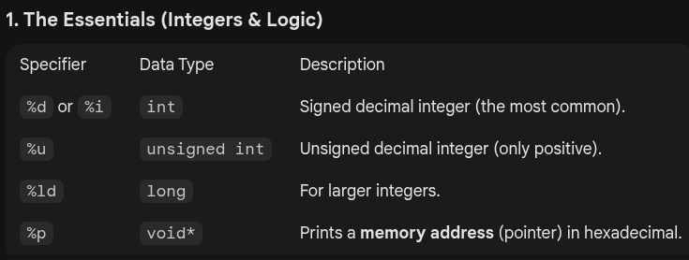
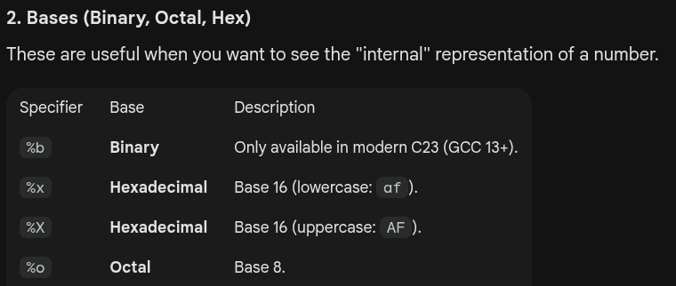
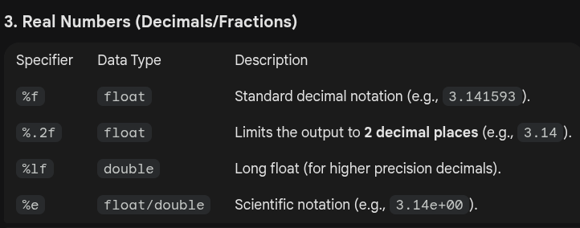
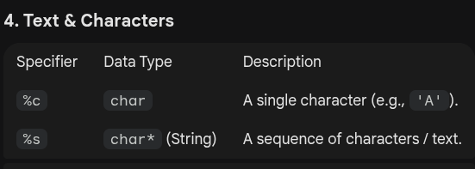
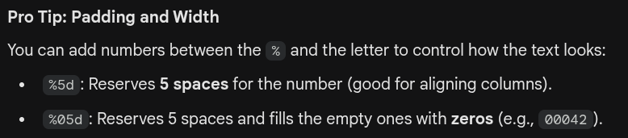
Bitwise Shift Operators:

Right:
a >> x

example:
a = (111)₂
a >> 1 = (011)₂

shifting a number to the right by the value of x is the same as dividing it with 2^{x}

Left:
a << x

example:
a = (111)₂
a << 1 = (1110)₂

shifting a number to the left by the value of x is the same as multiplying it with 2^{x}

